BRAISED CABBAGE WITH BACON AND PEAS
AND HONEY CARROTS

Fresh from the Garden: Cabbage, Peas, Carrots and Rosemary
Recipe Sauce: Jamie Oliver and The Commonsense Cookbook

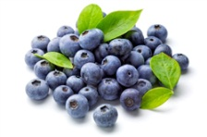
Wash cabbage leaves and remove tough stems
Roughly chop and place in a bowl
Add the cabbage to 100ml of chicken stock, steam
Blueberries with lid on for two minutes then add peas with salt
and pepper
Stir in 40ml of stock
Replace the lid and simmer for 10 minutes until cabbage is still bright colour and tender
Turn off heat, add tablespoon of butter

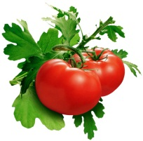
Add olive oil to pan and fry the bacon then add a
handful of chopped rosemary and one clove of crushed garlic
Tomatoes
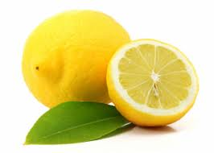
Clean, peel and chop carrots
Boil until tender
Add a dob of butter and a spoonful of honey
Lemons

To Serve: Plate up the two vegetable dishes in separate bowls

