In the Kitchen

BROAD BEAN SALSA WITH LETTUCE AND EATON MESS

FRESH FROM THE GARDEN: Broad Beans, Tomatoes, Cucumber, Spring
Onions, Garlic and Strawberries
RECIPE SOURCE: Broad Bean Salsa – Fiona Maine
Easton Mess – Stephanie Alexander

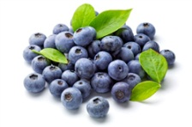
Broad Bean Salsa
Shell Broad Beans; Drop into pot of boiling
Blueberries water for 4 to 5 minutes and then plunge into ice-cold
water to stop the cooking process. When cooled, pinch
the bottom of the bean and squeeze to quickly pop it out
of it’s tough skin.
Wash and dice tomatoes and cucumber. Combine all
ingredients in a large bowl.
Mix in dressing from Lemons Group.

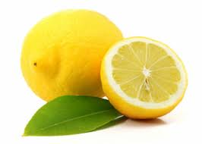
Dressing
Mix 2 tablespoons fish sauce, ¼ cup water, 2 tablespoons
castor sugar, 2 tablespoons lime juice and ½ crushed
garlic clove. Put all ingredients in a jar with a lid and
Lemons shake, shake, shake!
Wash and finely chop the spring onions (add to
the salsa) from the Blueberries Group.
Wash, spin dry and finely shred lettuce.

To Serve: Make a bed of lettuce and top with the
salsa from the Blueberries Group.

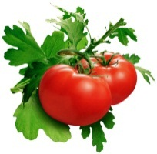
Eaton Mess
Blend 250g raspberries, the juice of 1 lemon and ½ cup of
castor sugar in a food processor until shiny and sugar
Tomatoes crystals have disappeared. Press through a course
sieve to extract seeds. Taste for sweetness. Cover and
refrigerate.
Whip cream.
Cut strawberries in half and combine with crushed
meringue and a spoonful of raspberry sauce, then fold
mixture into enough whipped cream to make a gloriously
marbled crimson-and-white dessert.

To Serve: Spoon into clear cups.

