In the Kitchen

Cabbage with Tomato topped Au Gratin
FRESH FROM THE GARDEN: Cabbage
RECIPE SOURCE: Joy of Cooking
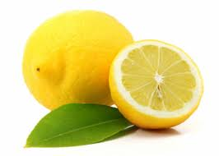
Blueberries Tomatoes Lemons

Ingredients:
3cups finely shredded cabbage
1 can condensed tomato soup
¼ teaspoon paprika
2 teaspoons brown sugar
Ingredients for Au Gratin
Dry bread crumbs
Dots of butter
Grated cheese
½ teaspoon paprika per cup of mix

Method:
- Preheat oven to 200 degrees celsius
- Mix soup with paprika and sugar.
- Butter a baking dish.
- Place in alternate layers of cabbage and the soup mixture.
- Completely cover the top with Au Gratin mix.
- Bake for ½ hr.

